Module: Python

**Q1. Write code to convert the below Dictionary in Pandas Dataframe:**

      Dictionary:  `dct = [{'2022-03-31': {'A': 12323, 'B': 123123}},{'2021-03-31': {'A': 12, 'B': 123}}]`  
        
Expected Output:df is dataframe  
```         
>> df  
            Date         A         B

    0 2022-03-31 12323 123123

    1 2021-03-31     12         123  
```

**Code:**

import pandas as pd

dct = [{'2022-03-31': {'A': 12323, 'B': 123123}}, {'2021-03-31': {'A': 12, 'B': 123}}]

dataList = []

for entry in dct:

    date, valueDict = list(entry.items())[0]

    valueDict['Date'] = date

    dataList.append(valueDict)

df = pd.DataFrame(dataList)

df = df[['Date', 'A', 'B']]

print(df)

**Output:   
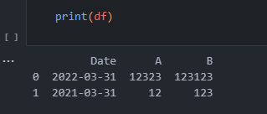**

**Q2. Write a Python code to count the Sum of positive and negative numbers that are below 40 in the below list**.

list = [10,-20,30,40,-50,60,12,-12,11,1,90,-20,-10,-5,-4]  
  
Expected Output:  
```  
The sum of positive elements in the list below 40: X  
The sum of negative elements in the list below is 40: Y  
```

**Code:**

list = [10, -20, 30, 40, -50, 60, 12, -12, 11, 1, 90, -20, -10, -5, -4]

positivesum = 0

negativesum = 0

for num in list:

    if num < 40:

        if num > 0:

            positivesum += num

        elif num < 0:

            negativesum += num

print(f"The sum of positive elements in the list below 40: {positivesum}")

print(f"The sum of negative elements in the list below 40: {negativesum}")

**Output:**

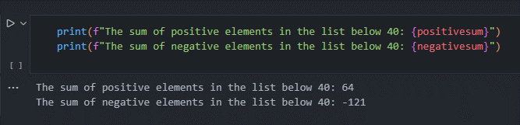

Module: Linux

**Q1. Write a Shell script that will do the following.  
      i) Check Linux OS, which Linux distribution is present in the machine. E.g., Ubuntu, Cent OS  
      ii) Check whether application ‘httpd’ is installed or not on the Linux machine,  
      iii) If ‘httpd’ is not installed, install httpd  
      iv) check the status of the httpd application whether its status is running or not  
      v) If the status of the ‘httpd’ application is not running then start the application**

Code:

#!/bin/bash

# Check Linux OS distribution

if [ -f /etc/os-release ]; then

    source /etc/os-release

    echo "Linux Distro: $NAME"

    echo "Linux Distro Family: $ID_LIKE"

else

    echo "Unknown Linux Distro"

fi

# Check if 'httpd' is installed

if command -v httpd >/dev/null 2>&1; then

    echo "httpd is already installed."

else

    echo "httpd is not installed. Installing httpd..."

    # Install httpd based on the OS family

    if [[ $ID_LIKE == *"debian"* ]]; then

        # Debian-based distributions

        sudo apt update

        sudo apt install -y apache2

    elif [[ $ID_LIKE == *"rhel fedora"* ]]; then

        # Red Hat-based distributions

        sudo yum update

        sudo yum install -y httpd

    elif [[ $ID_LIKE == *"suse"* ]]; then

        # SUSE-based distributions

        sudo zypper refresh

        sudo zypper install -y apache2

    elif [[ $ID == "arch" || $ID_LIKE == *"archlinux"* ]]; then

        # Arch Linux-based distributions

        sudo pacman -Syu --noconfirm

        sudo pacman -S --noconfirm apache

    else

        echo "Unsupported Linux distro. Please install 'httpd' manually."

        exit 1

    fi

fi

# Check the status of httpd application

if sudo systemctl is-active httpd >/dev/null 2>&1; then

    echo "httpd is running."

else

    # Start httpd application if it's not running

    echo "httpd is not running. Starting httpd..."

    sudo systemctl start httpd

fi

Output:

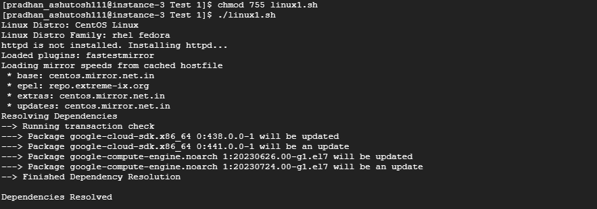

**Q2. i) Write Linux commands to check the storage of each folder present in ‘/home’ directory.  
      ii) Write a Linux command to check CPU Utilization, RAM, and Number of CPU Cores.**  
Code:

Output: